# Integration

Review Section 1.2.2 in Goldsman, D. & Goldsman, P. (2020). A First Course in Probability and Statistics. Lulu. [Download link](https://www.lulu.com/search?page=1&q=goldsman&pageSize=10&adult_audience_rating=00)

Other resources that are helpful when reviewing calculus are:

[Paul’s Online Math Notes](https://tutorial.math.lamar.edu/)

[Khan Academy](https://www.khanacademy.org/)

[YouTube](https://www.youtube.com/results?search_query=Calculus)

<https://math.libretexts.org/Bookshelves/Calculus>

# Integration by Parts

To use integration by parts, we choose one part of the integrand to be differentiated and the other part to be integrated. This is done by selecting [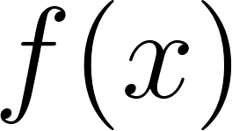](https://www.codecogs.com/eqnedit.php?latex=f(x)#0) and [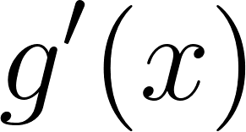](https://www.codecogs.com/eqnedit.php?latex=g'(x)#0) in such a way that [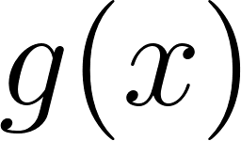](https://www.codecogs.com/eqnedit.php?latex=g(x)#0) can be easily integrated. This method can be used iteratively to simplify complex integrals involving products of two functions.

Consider the integral of [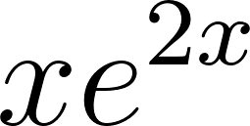](https://www.codecogs.com/eqnedit.php?latex=x%20e%5E%7B2x%7D#0) over the interval [](https://www.codecogs.com/eqnedit.php?latex=%5B0%2C%201%5D#0). To solve this integral using integration by parts, we can select [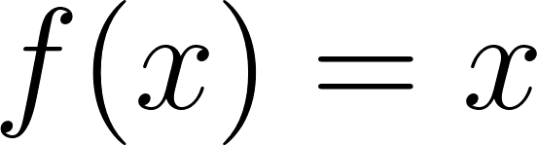](https://www.codecogs.com/eqnedit.php?latex=f(x)%20%3D%20x#0) and [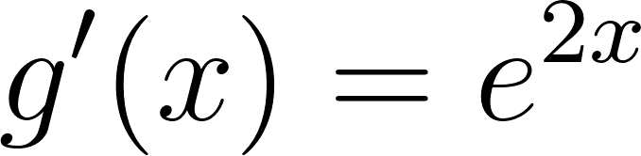](https://www.codecogs.com/eqnedit.php?latex=g'(x)%20%3D%20e%5E%7B2x%7D#0). Then, [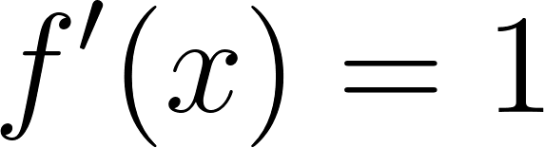](https://www.codecogs.com/eqnedit.php?latex=f'(x)%20%3D%201#0) and [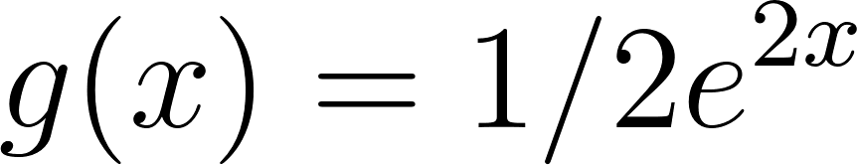](https://www.codecogs.com/eqnedit.php?latex=g(x)%20%3D%201%2F2%20e%5E%7B2x%7D#0). Notice that [](https://www.codecogs.com/eqnedit.php?latex=g(x)#0) is something that is easily integrated.

# Maclaurin Friends

[Taylor series expansion and Maclaurin series](https://en.wikipedia.org/wiki/Taylor_series) are important concepts in calculus that are used to approximate functions using polynomials. They are useful when the function itself is difficult to integrate or differentiate, but its derivatives can be easily calculated.

A Taylor series expansion is an infinite sum of terms that represents a function as a polynomial. The Taylor series expansion is essentially an infinite sum of derivatives of f(x) evaluated at the point a, multiplied by powers of (x-a). The series can be truncated to a finite number of terms to approximate the function around a.

A Maclaurin series is a special case of the Taylor series expansion, where the expansion is done around x=0. Like the Taylor series, the Maclaurin series can be truncated to a finite number of terms to approximate the function around x=0.

Taylor series and Maclaurin series are important because they provide a way to approximate complex functions using simple polynomials. They can be used to approximate functions in various fields such as physics, engineering, economics, and finance. For example, they can be used to approximate the behavior of a system in [control theory](https://en.wikipedia.org/wiki/Control_theory), to model [financial derivatives](https://en.wikipedia.org/wiki/Derivative_(finance)), to estimate the error of [numerical methods](https://en.wikipedia.org/wiki/Numerical_method), and to solve [differential equations](https://en.wikipedia.org/wiki/Differential_equation).

As an example, suppose we want to evaluate the function [](https://www.codecogs.com/eqnedit.php?latex=e%5Ex#0) around [](https://www.codecogs.com/eqnedit.php?latex=x%3D0#0). Using the Maclaurin series, we have:

[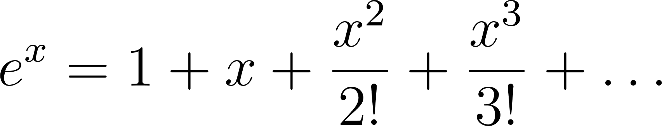](https://www.codecogs.com/eqnedit.php?latex=e%5Ex%20%3D%201%20%2B%20x%20%2B%20%5Cdfrac%7Bx%5E2%7D%7B2!%7D%20%2B%20%5Cdfrac%7Bx%5E3%7D%7B3!%7D%20%2B%20%5Cdots#0)

Truncating the series to the first two terms, we get:

[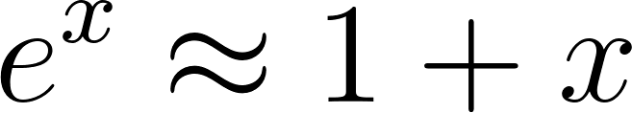](https://www.codecogs.com/eqnedit.php?latex=e%5Ex%20%5Capprox%201%20%2B%20x#0)

This is a good approximation of [](https://www.codecogs.com/eqnedit.php?latex=e%5Ex#0) when [](https://www.codecogs.com/eqnedit.php?latex=x#0) is close to 0. In practice, the series can be truncated to a larger number of terms to obtain a more accurate approximation of the function.

## Maclaurin Friends Example R Code

*# Create a sequence of values for the variable x using the seq() function*  
x <- seq(-0.2, 0.2, by = 0.05)  
  
*# Calculate the true values of e^x for each value of x using the exp() function*  
true_val <- exp(x)  
  
*# Calculate the approximate values of e^x using the formula 1 + x*  
approx_val <- 1 + x  
  
*# Combine the true_val and approx_val vectors, along with their absolute*   
*# difference into a data frame using x as the row labels for the data frame*  
df <- data.frame(true_val = true_val, approx_val = approx_val,  
 abs_diff = abs(approx_val - true_val),  
 row.names = x)  
  
*# Print the resulting data frame*  
print(df)

## true_val approx_val abs_diff  
## -0.2 0.8187308 0.80 0.018730753  
## -0.15 0.8607080 0.85 0.010707976  
## -0.1 0.9048374 0.90 0.004837418  
## -0.05 0.9512294 0.95 0.001229425  
## 0 1.0000000 1.00 0.000000000  
## 0.05 1.0512711 1.05 0.001271096  
## 0.1 1.1051709 1.10 0.005170918  
## 0.15 1.1618342 1.15 0.011834243  
## 0.2 1.2214028 1.20 0.021402758

*# Check if the true_val and approx_val vectors are equal within a tolerance*  
*# of numerical accuracy*  
all.equal(true_val, approx_val)

## [1] "Mean relative difference: 0.009310572"

## Maclaurin Friends Example Python Code

[Python Notebook](https://colab.research.google.com/drive/18f85SWi1CqguAD9oYaGNt3Y58hvDAZKE)

# L’Hospital’s Rule

[L'Hospital's Rule](https://en.wikipedia.org/wiki/L%27H%C3%B4pital%27s_rule) is a method used in calculus to evaluate limits of [indeterminate forms](https://en.wikipedia.org/wiki/Indeterminate_form). These are expressions where the limit of a function as x approaches a certain value is undefined or results in an indeterminate form (such as 0/0 or [](https://www.codecogs.com/eqnedit.php?latex=%5Cinfty%2F%5Cinfty#0)).

If we have an indeterminate form of the type 0/0 or [](https://www.codecogs.com/eqnedit.php?latex=%5Cinfty%20%2F%20%5Cinfty#0), we can apply L'Hospital's Rule by taking the derivative of the numerator and denominator, and then evaluating the limit of the resulting quotient.

L'Hospital's Rule is important because it provides a powerful tool for evaluating limits that are difficult or impossible to evaluate using other methods. It is widely used in calculus and other areas of mathematics, such as differential equations and [complex analysis](https://en.wikipedia.org/wiki/Complex_analysis).

In the real world, L'Hospital's Rule has many practical applications. It can be used in engineering to calculate the stress on a structure when a force is applied, in physics to evaluate the velocity and acceleration of a moving object, and in finance to calculate interest rates and returns on investments.